DEPARTMENT OF BASIC SCIENCES AND ISLAMIAT
University of Engineering and Technology, Peshawar Campus
Linear Algebra (BSI-111)
Assignment NO.1

Q1.a) A plastics manufacturer makes two type of plastic regular and special each ton of
Regular plastic requires 2 hours in plant A and 5 hours in plant B; each ton of special
Plastic requires 2 hours in plant A and 3 hours in plant B. If plant A is available 8
Hours per day and plant B is available 15 hours per day, how many tons of each
Type of plastic can be made daily so that the plants are fully utilized?
b) Some matrix transformation f have the property that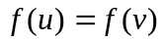, when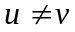.
For the matrix transformation 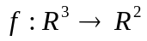defined by f (u) =Au, find the two different
Vector u and v such that 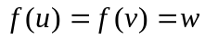for the given vector w.
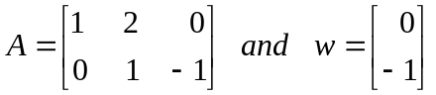
Q2 .a) Let be 3- vector denoting the current prices of three items at stores A & B, respectively.
- Obtain a 2 x 3 matrix representing the combined information about the prices of the three items at the two stores.
- Suppose that each store announces a sale so that the price of each items is reduced by 20% obtain a 2 x 3 matrix representing the sale prices at the two stores.
b) Construct a linear system of equations to determine a quadratic polynomial 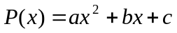 that satisfies the conditions
Q3. a) Find an LU-factorization of the of the co-efficient matrix of the given linear system Ax = b. solve the linear system using a forward substitution followed by a back substitution.
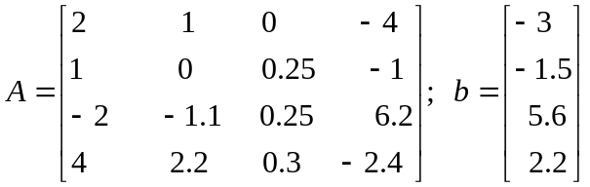
b) The matrix transformation 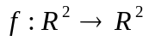defined by 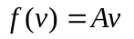where
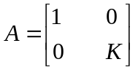
Where K is a real number is called dilation in the y- direction 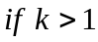 and contraction in the y- direction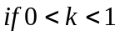. If R is the unit square and f is the contraction in the y-direction with 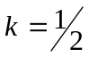 , find and sketch the image of R.
Q4. Suppose that the weather in a certain city is either rainy or dry. As a result of extensive
record keeping it has been determined that the probability of a rainy day following a dry
day is , and the probability of a rainy day following a rainy day is . Let state D be a
dry day and state R be a rainy. Then the transition matrix of this Markov chain is

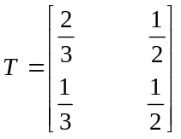
- If 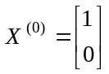, compute 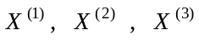 to three decimal places.
- Show that T, is regular and find its steady-state vector.

Q5. (a) The matrix transformation defined by where
Where K is a real number is called dilation in the y- direction if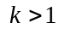 and contraction in the y- direction if 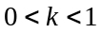. If R is the unit square and f is the contraction in the y-direction with , find and sketch the image of R

(b) Consider the transition matrix

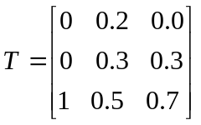
Show that T is regular and find its steady-state vector.
Q6. (a) Some matrix transformation f have the property that, when.
For the matrix transformation defined by f (u) =Au, find the two different
Vector u and v such that for the given vector w.
(b) Solve the linear system Ax=b with the given LU-factorization of the of the co-efficient
Matrix A. Solve the linear system using a forward substitution Followed By a back
Substitution.
